Name: ______________________ Due date: ____________

**Year 9 Physics Investigation**

[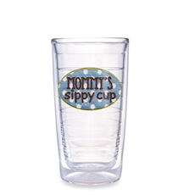](http://www.bedbathandbeyond.com/1/1/69464-tervis-tumbler-mommys-sippy-cup-16-ounce-tumbler.html)

[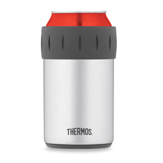](http://www.bedbathandbeyond.com/1/1/58818-thermos-vacuum-insulated-beverage-can-insulator.html)[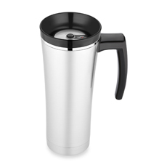](http://www.bedbathandbeyond.com/1/1/58809-thermos-sipp-vacuum-insulated-travel-mug-black.html)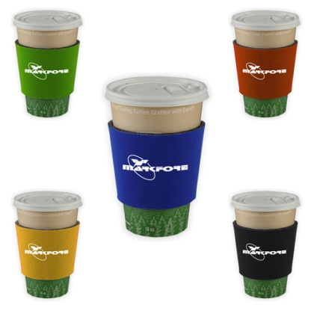

You have been hired by a thermos manufacturing company to conduct research into the development of the best materials to use as insulators in their new designs.

Heat transfer occurs via conduction when heat is passed by vibration of particles.

Your task is to compare two types of materials as possible insulators for the company to use in their new products.

Your conclusion will include the scientific reasons why the suggest material would be the best insulator for the company to use.

Ref. pg 109-110 in Pearson 9

Name:_______________________________ Class:__________________

|  |  |  |  |
| --- | --- | --- | --- |
| **Part** | **Details** | **Available**  **mark** | **Your**  **mark** |
| Title | Descriptive NOT Physics Investigation | 1 |  |
| Aim |  | 1 |  |
| Hypothesis | Correctly worded  Includes dependent and independent variables | 2 |  |
| Variables | Independent  Dependent  Controlled | 4 |  |
| Materials | Complete  Listed | 2 |  |
| Method | Step by step with numbers  Written in past tense  Complete  Labelled Diagrams  Explain how reliable results are achieved | 1  1  1  2  2 |  |
| Results | Table - neat & clear with units | 3 |  |
| Graph | Showing two cooling rates over time for both type of material tested  Includes Title, labels on each axis, correct units, regular spaced, legend for each line graph | 5 |  |
| Discussion | Errors  Effects of errors  Solutions | 1  1  1 |  |
| Conclusion | What did the results show ?  Use figures from your results  Does this support your hypothesis?  Suggest best insulator type for use –give Scientific reasons | 1  1  1  3 |  |
| **Total mark** | | **34** |  |

**TITLE: ____________________________________________________** (1 mark)

AIM: **_____________________________________________________** (1 mark)

1. What is the independent variable? (the factor you changed)

(1 mark)

2. What is the dependent variable? (the factor you measure)

(1 mark)

3. List the controlled variables? (the factors you keep the same)

__________________________________________________________

(2 marks)

4. Write a hypothesis (2 marks)

5. Materials List the Materials apparatus/equipment you will use? (2 marks)

6. Method : Write, in point form, what you plan to do in your experiment. (3 marks)

(step by step with numbers, write in past tense, is complete)

____________________________________________________________________

Labelled Diagrams of your equipment (2 marks)

How will your group make sure reliable results are obtained? (2 marks)

**TABLE:** Record your results in an **appropriate** table into this space.

(neat and clear – include units) (3 marks)

What type of graph will best suit your results?

_________________________________________________________

3. Draw the graph. (5 marks)

|  |  |  |  |  |  |  |  |  |  |  |  |  |  |  |  |  |  |  |  |  |  |  |  |  |  |  |
| --- | --- | --- | --- | --- | --- | --- | --- | --- | --- | --- | --- | --- | --- | --- | --- | --- | --- | --- | --- | --- | --- | --- | --- | --- | --- | --- |
|  |  |  |  |  |  |  |  |  |  |  |  |  |  |  |  |  |  |  |  |  |  |  |  |  |  |  |
|  |  |  |  |  |  |  |  |  |  |  |  |  |  |  |  |  |  |  |  |  |  |  |  |  |  |  |
|  |  |  |  |  |  |  |  |  |  |  |  |  |  |  |  |  |  |  |  |  |  |  |  |  |  |  |
|  |  |  |  |  |  |  |  |  |  |  |  |  |  |  |  |  |  |  |  |  |  |  |  |  |  |  |
|  |  |  |  |  |  |  |  |  |  |  |  |  |  |  |  |  |  |  |  |  |  |  |  |  |  |  |
|  |  |  |  |  |  |  |  |  |  |  |  |  |  |  |  |  |  |  |  |  |  |  |  |  |  |  |
|  |  |  |  |  |  |  |  |  |  |  |  |  |  |  |  |  |  |  |  |  |  |  |  |  |  |  |
|  |  |  |  |  |  |  |  |  |  |  |  |  |  |  |  |  |  |  |  |  |  |  |  |  |  |  |
|  |  |  |  |  |  |  |  |  |  |  |  |  |  |  |  |  |  |  |  |  |  |  |  |  |  |  |
|  |  |  |  |  |  |  |  |  |  |  |  |  |  |  |  |  |  |  |  |  |  |  |  |  |  |  |
|  |  |  |  |  |  |  |  |  |  |  |  |  |  |  |  |  |  |  |  |  |  |  |  |  |  |  |
|  |  |  |  |  |  |  |  |  |  |  |  |  |  |  |  |  |  |  |  |  |  |  |  |  |  |  |
|  |  |  |  |  |  |  |  |  |  |  |  |  |  |  |  |  |  |  |  |  |  |  |  |  |  |  |
|  |  |  |  |  |  |  |  |  |  |  |  |  |  |  |  |  |  |  |  |  |  |  |  |  |  |  |
|  |  |  |  |  |  |  |  |  |  |  |  |  |  |  |  |  |  |  |  |  |  |  |  |  |  |  |
|  |  |  |  |  |  |  |  |  |  |  |  |  |  |  |  |  |  |  |  |  |  |  |  |  |  |  |
|  |  |  |  |  |  |  |  |  |  |  |  |  |  |  |  |  |  |  |  |  |  |  |  |  |  |  |
|  |  |  |  |  |  |  |  |  |  |  |  |  |  |  |  |  |  |  |  |  |  |  |  |  |  |  |
|  |  |  |  |  |  |  |  |  |  |  |  |  |  |  |  |  |  |  |  |  |  |  |  |  |  |  |
|  |  |  |  |  |  |  |  |  |  |  |  |  |  |  |  |  |  |  |  |  |  |  |  |  |  |  |
|  |  |  |  |  |  |  |  |  |  |  |  |  |  |  |  |  |  |  |  |  |  |  |  |  |  |  |
|  |  |  |  |  |  |  |  |  |  |  |  |  |  |  |  |  |  |  |  |  |  |  |  |  |  |  |
|  |  |  |  |  |  |  |  |  |  |  |  |  |  |  |  |  |  |  |  |  |  |  |  |  |  |  |
|  |  |  |  |  |  |  |  |  |  |  |  |  |  |  |  |  |  |  |  |  |  |  |  |  |  |  |
|  |  |  |  |  |  |  |  |  |  |  |  |  |  |  |  |  |  |  |  |  |  |  |  |  |  |  |
|  |  |  |  |  |  |  |  |  |  |  |  |  |  |  |  |  |  |  |  |  |  |  |  |  |  |  |

(Remember: Title, Label Axis, Measurements, Regular Scale, Neat , Accurate graphing,

Use Pencil, Use legend for each type of material tested)

**Discussion** . How could the fairness /accuracy of the experiment be improved? (3 marks)

Errors

_______________________________________________________________

Effect of Errors

_______________________________________________________________

Ways to improve experiment

_______________________________________________________________

#### CONCLUSION

What did the results show? Use figures from your results (2marks)

Does this support your hypothesis? (1mark)

_______________________________________________________________

Suggest the best insulator type for the company to use --- give scientific reasons

as to why it would be the best (3 marks)